Invest in:

- Public Health
- New Environmental Technologies
- Fair Labor
- Low-income Area Housing & Business

Reform These Companies or Dump Them

Hold TIAA-CREF Accountable
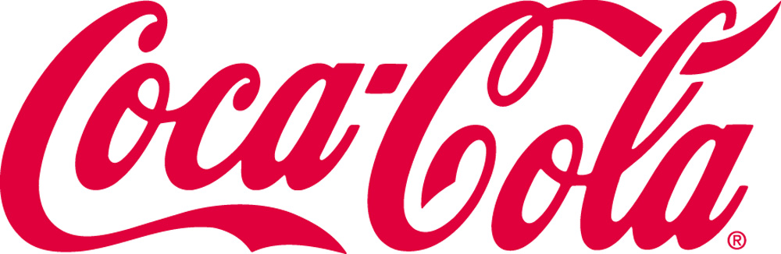

Nike
WalMart

World Bank Bonds
Philip-Morris/Altria
Costco
Chevron

